ECC Recommendation (YY)XX

Recommendation title (Arial 12pt)
Approved DD Month YYYY (Arial 9pt bold)
[last updated: DD Month YYYY) (Arial 9pt) [date of the latest update]]

introduction (style: heading 1)
Body text (style: ECC Paragraph)…

ECC recommendation of YY(XX) on title (style: Heading 1)
“The European Conference of Postal and Telecommunications Administrations, (style: ECC paragraph)
considering (style: ECC Paragraph, Arial 10pt italic red (colour values RGB: 210, 35, 42))
- lettered list (style: Lettered List)

- final point in list should have paragraph spacing after: 12pt
recommends
- that (style: ECC Paragraph, sentence starts with lower case)
- that.
- that .”

Note:
Please check the Office documentation database https://docdb.cept.org/ for the up to date position on the implementation of this and other ECC Recommendations.

- List of References - see A2.2.3

- ECO instructions for the ECC Recommendation template
  - Introduction and general guidance
This annex contains instructions on the use of the ECC Recommendation template. Please read carefully before commencing work on a new draft ECC Report. This annex should be deleted before finalisation of the document. It is suggested to save a separate copy of these instructions for reference.

- Consider the ECC Style Guide and Use of ECC brand identity;
- Passive voice is used in the ECC deliverables (see ECC Style Guide 2.2);
- Frequency ranges are normally written as “1500-1700 MHz”. In some specific cases “from 1500 to 1700 MHz” can be used;
- The language is British English (see ECC Style Guide 2.4) – note in particular “-ise” instead of “-ize” – e.g. “harmonise”, “desensitise”;
- Write numbers ‘one’ to ‘nine’ and ‘first’ to ‘ninth’ in full. 10 and above should appear as figures. Use preferably the following convention for numbers. Example of a number: “100000.00” (see ECC Style Guide 2.8). No separators used for large numbers, decimal points should use a dot “.”, 2 decimal places preferred (where applicable);
- Units should be separated with a space, e.g. “5 m”, 60 dB” or “45 MHz”. Emission limits specified per bandwidth are written as “10 dBm/kHz” or “10 dBm/(4 kHz)”
- Date format: “23 November 2011” (see ECC Style Guide 2.7);
    - Instructions on abbreviations
- Abbreviations (uncapitalised) should be spelt out the first time they are used in the document, e.g.: "fixed service (FS)"., with the exception of commonly understood terms. Note special format for “e.i.r.p.”, “pfd”
- Radiocommunications services are uncapitalised (“fixed service”, “mobile service”), also “base station” and “earth station”
    - Instructions on the template
- For assistance on an introduction and an overview of the template, please contact the ECO expert;
- For issues with the locked template, please contact editorial@eco.cept.org. You may contact ECO when the problem occurs or you may request a future booking. ECO usually replies within one working day;
- ECO is to review the final deliverable before it is submitted to the Working Group:
The correct template must be used;
The list of abbreviations must be finalised and consistent with abbreviations used;
The list of references must be finalised and consistent, see example in A3.2.6;
ECO needs to have at least two working days for finalising the editorial work before it is submitted to the Working Group.
  - Instructions for specific sections
    - List of abbreviations
- During drafting phase and public consultation, the table format will appear with a frame for ease of editing;
- Before publication, ECO will reformat the table without visible frames;
- The rapporteur is to add all abbreviations, references and explanations before the draft is submitted to the working group for public consultation approval;
- During public consultation, ECO will only check consistency in the list of abbreviations;
- Organisations’ names are to be written in English where applicable.
- If translated English titles of national organisations are used include the country name in brackets, e.g.:
BNetzA = Federal Network Agency (Germany);
ANFR = National Frequency Agency (France)
    - Introduction
The introduction should succinctly provide the background and context to the work and outline the main aims of the report.
    - List of references
- The List of references is always the last annex of the ECC Report;
- The rapporteur is to add all list of references before the draft is submitted to the working group for public consultation approval;
- During public consultation, ECO will only check consistency in the list of references;
- Titles are to be copied in as they appear in the source, so spelling and numbering may be different from the standard ECC style;
- If hyperlinks are provided the full link must be shown;
- The rapporteur is to decide and add version number and date if relevant.
      - Information about references to ECC deliverables:
- If a draft version of an ECC deliverable is used, the reference has to show that a draft version is used. A footnote shall be added and the text “expected to be approved MM YYYY”. ECO keeps track of this and will update in https://docdb.cept.org/ accordingly;
- Only approved ECC deliverables should be referenced. ECC input documents are only used as a reference in exceptional cases;
- ECO is to keep a copy of the file together with the approved ECC deliverable in case of external requests.
- For cases of multiple references to the same document within the main body, only include cross-references the first time on each page or sub-section. In tables, cross references are allowed on each line (see above example).Examples of references

For an ECC Report:
- ECC Report 217: "The Use of Land, Maritime and Aeronautical Earth Stations on Mobile Platforms Operating with NGSO FSS Satellite Systems in the Frequency Range 17.3-20.2 GHz, 27.5-29.1 GHz and 29.5-30.0 GHz”, approved February 2015, latest amendment January 2020

For an ECC Recommendation:
- ECC Recommendation (15)01: “Cross-border coordination for Mobile/Fixed Communications Networks (MFCN) in the frequency bands: 694-790 MHz, 1427-1518 MHz and 3400-3800 MHz”, approved February 2015, latest amendment February 2020

For an ECC Decision:
- ECC Decision (19)04: “The harmonised use of spectrum, free circulation and use of earth stations on-board aircraft operating with GSO FSS networks and NGSO FSS systems in the frequency bands 12.75-13.25 GHz (Earth-to-space) and 10.7-12.75 GHz (space-to-Earth)”, approved March 2020

For a CEPT Report:
- CEPT Report 074: “Report from CEPT to the European Commission in response to the Mandate on spectrum for the future railway mobile communications system, Report A: Spectrum needs and feasibility (tasks 1 to 4)”, approved 3 July 2020

For an EC document (Decision or Directive):
- Commission Implementing Decision (EU) 2019/784 of 14 May 2019 on Harmonisation of the 24,25-27,5 GHz frequency band for terrestrial systems capable of providing wireless broadband electronic communications services in the Union
- Directive 2014/53/EU of the European Parliament and of the Council of 16 April 2014 on the harmonisation of the laws of the Member States relating to the making available on the market of radio equipment and repealing Directive 1999/5/EC

For an ETSI standard/specification/report (EN/TS/TR):
- ETSI EN 303 980 ([Version number], date): “Harmonised EN for fixed and in-motion Earth Stations communicating with non-geostationary satellite systems (NEST) in the 11 GHz to 14 GHz frequency bands covering essential requirements of article 3.2 of the Radio Equipment Directive 2014/53/EU”
- Rapporteur is to add version number and date if a specific version is used

For an ITU Report/Recommendation:
- Recommendation ITU-R F.1494: “Interference criteria to protect the fixed service from time varying aggregate interference from other services sharing the 10.7-12.75 GHz band on a co-primary basis”
- Report ITU-R SM.2421-0 (06/2018): "Unwanted emissions of digital radio systems"
- Rapporteur is to add version number and date if a specific version is used

For a journal paper:
- Flood, I.D and Allen S.M: “The Fixed Links Frequency Assignment Problem with Equipment Selection”, Wireless Pers Commun, vol. 71, pp. 181-194, 2012

For 3GPP specifications/reports:
- 3GPP TS 37.104 V[X.Y.Z]: “E-UTRA, UTRA and GSM/EDGE; Multi-Standard Radio (MSR) Base Station (BS) radio transmission and reception, (Release 10)”
- 3GPP TR 36.942 V[X.Y.Z], Evolved Universal Terrestrial Radio Access (E-UTRA); Radio Frequency (RF) system scenarios, (Release 8)
- Rapporteur is to add version number and date if a specific version is used
  - Style for referring to other publications inside the Report
- ECC Report 200, annex 2.5 [1]
- ETSI EN 302 208, figure 1 [2]
- TS 36.101, table 6.6.2.1.1-1 [7]
- CEPT Report 39, annex 3 [40]
- Recommendation ITU-R M.2101, section 3.4.1 [23]
- Recommendation ITU-R M.2101, page 79 [23]
  - Figures
    - General instructions for figures
- Figure captions are positioned below the figure.
- In the figure caption, only the first letter of the title is capitalised; all other words shall not be capitalised unless they are terms that would normally be capitalised);
- Figure captions are without a full stop at the end;
- Figure captions are advised to be concise as possible, recommended one line. If text is longer than one line, please add the explanation as text before or after the figure;
- The figure and figure title is to be centred by using the style “ECC Figure/graph centered”;
- Figures shall use automatic numbering - Arabic numerals, beginning with 1.. ascending numbering throughout the ECC deliverable, i.e. "Figure 1:";
- Figures are to be inserted “in line with text”
- If two figures need to be next to each other then right click on the figure, select Wrap Text and Square option.
    - How to insert a figure caption
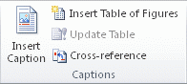
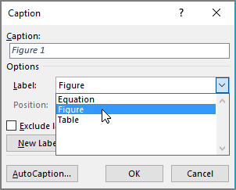

    - Example of a figure
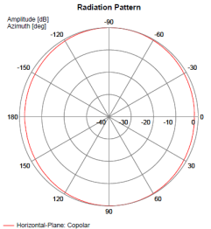
Figure 1: Cab-radio horizontal antenna pattern at 880 MHz
  - Tables
    - General instruction for tables
- Table captions are positioned above the table;
- In the table caption, only the first letter of the title is capitalised; all other words shall not be capitalised unless they are terms that would normally be capitalised);
- Table captions are without a full stop at the end;
- Table captions are advised to be concise as possible, recommended one line. If text is longer than one line, please add the explanation as text before or after the table;
- The table and table caption are to be centred by using the style “ECC Figure/graph centred”;
- Tables shall use automatic numbering - Arabic numerals, beginning with 1.. ascending numbering throughout the ECC deliverable, i.e. "Table 1:";
- Notes shall be descriptive and concise, if more text is needed put it below/above the table;
- Figures are not allowed in table notes, they are to be placed below/above the table;
- If your table needs a different layout such as two red header rows, please contact editorial@eco.cept.org, ECO will fix this and reply within one working day;
- If the table is longer than a page length, the table number and title as well as column headings shall be repeated on each page. The template is designed to apply this automatically;
- Avoid copying and pasting tables as pictures. If this is necessary, add a reference from where the table was copied.
    - How to insert a table caption
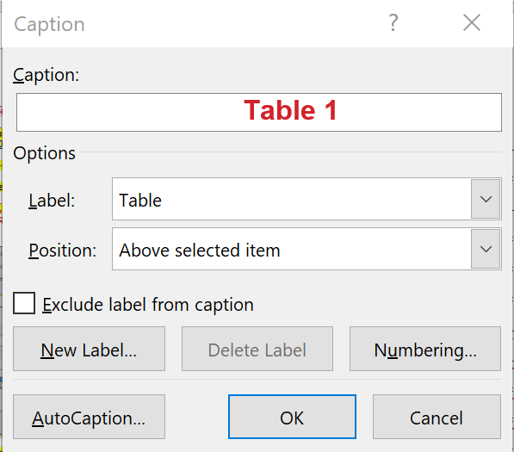
    - How to insert a table
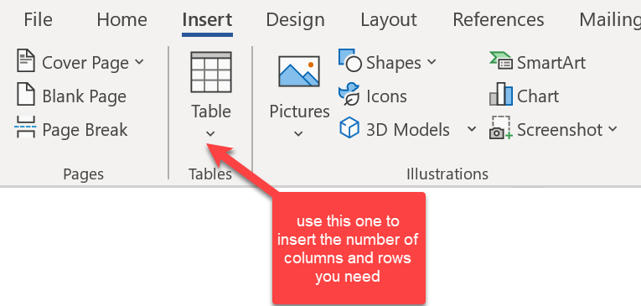
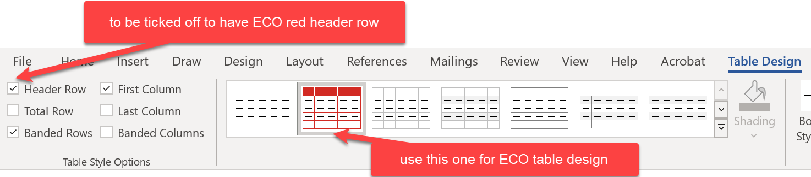

- If this does not work according to your expectations, please contact editorial@eco.cept.org with instructions, ECO will aim to reply within one working day;

    - Information on different kind of tables
Table 1: Standard table format
Table style: ECC Table – red header  Centred margin (Note 1) | Table style: ECC Table – red header  Centred margin
Example of a subheading
Text left margin  Margin 0 cm  Style: ECC Table text | Text left margin  Margin 0 cm  Style: ECC Table text
Text left margin  Margin 0 cm  Style: ECC Table text | Text left margin  Margin 0 cm (Note 2)  Style: ECC Table text
Note without a number refers to the entire table

Note 1: test to be tested, test to be tested, test to be tested test to be tested test to be tested test to be tested test to be tested test to be tested
Note 2: test
Note 3: notes with numbers are to be hanging 1 cm like in note 1 in order to ease readability
Example of a standard table:
Table 2: Requirements on RMR cab-radio receiver characteristics
Parameter | Value
Level of the wanted signal | Sensitivity +3 dB
Maximum 5 MHz LTE interfering signal in 880-915 MHz (Note 1) | -33 dBm (Note 2)
The antenna connector of the radio module is the reference point.
Note 1: This requirement covers both blocking and third-order intermodulation
Note 2: -36.2 dBm for a desensitization of 1.7 dB is equivalent to -33 dBm for a desensitization of 3 dB
Example of an alternative table layout with 2 heading rows:
Table 3: MFCN BS selectivity increase
RMR carrier | MFCN BS selectivity increase
 | compared to  CEPT Report 39 [4] | compared to  TS 137 104 [9]
10 MHz LTE/NR in 1900-1910 MHz | 24.3 dB | 40.6 dB
Example of an alternative table layout with merged cells:

Table 5: LTE/NR FRMCS high-power cab-radio characteristics
Parameter | FRMCS BS  900 MHz range | FRMCS BS  1900 MHz range |  | Reference
Channel bandwidth | LTE: 1.4 or 5 MHz  NR: 5 MHz | 10 MHz | ETSI TS 136 101 [10]  ETSI TS 138 101-1 [11]
 | NR: 5.6 MHz |  | Note
Occupied bandwidth | LTE: 1.08 or 4.5 MHz  NR: 4.5 MHz | LTE: 9 MHz  NR: 9.36 MHz | ETSI TS 136 101 [10]  ETSI TS 138 101-1 [11]
 | NR: 5.04 MHz |  | Note
Maximum output power | 31 dBm with UL power control |  | Railway industry’s request
Maximum e.i.r.p. | 33 dBm with UL power control
ACLR | 37 dB |  | ETSI TS 136 101 [10]  Power Class 1 (note 1)
Note: The 5.6 MHz channel bandwidth is considering a transmission bandwidth of 28 RB between 919.6725 and 924.7125 MHz, reflecting a possible 5.6 MHz NR channel. This is understood to be compatible with NR lower layers, subject to additional standardisation work, as necessary, to confirm and further specify this.
Note 1: For a Power Class 3 UE, ACLR is 30 dB.
  - Flow of ECC deliverables
